#include<stdio.h>

#include<string.h>

int main(){

char str[100],ch;

int i=0;

printf("Enter Expression (terminated by $):");

for(i=0;;i++) {

scanf("%c",&ch);

if(ch=='$')

break;

str[i]=ch;

}

str[i]='\0';

printf("Given Expression:%s\n",str);

int l=strlen(str);

i=0;

static int j=0;

printf("Lexxems\tAddress\tType\n");

while(i<l){

int o=0;

for(j=i;str[j]!='+' && str[j]!='-' && str[j]!='\*' && str[j]!='/' && str[j]!='=' && str[j]!='\0';j++){

printf("%c",str[j]);

}

if((str[i]<=90 && str[i]>=65) || (str[i]<=122 && str[i]>=97))

printf("\t%p\tIdentifier\n",&str[i]);

else if(str[i]<=57 && str[i]>=48)

{

int z=0;

for(int x=i+1;x<j;x++){

if(str[x]<=57 && str[x]>=48)

continue;

else

z=-1;

}

if(z!=0)

printf("\t%p\tInvalid Token\n",&str[i]);

else

printf("\t%p\tConstant\n",&str[i]);

}

if(str[j]=='+' || str[j]=='-' || str[j]=='\*' || str[j]=='/' || str[j]=='=')

{

if(str[j]==' ' && str[j+1]==' '){

printf("%c%c\t%p\t'\*\*' Operator\n",str[j],str[j+1],&str[j]);

o=-1;

}

else

printf("%c\t%p\tOperator\n",str[j],&str[j]);

}

if(o==0)

i=j+1;

else

i=j+2;

}

}

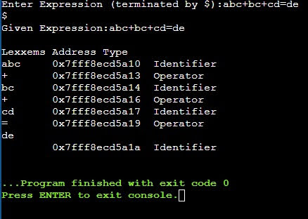Out put